From local conversation with Claude Opus 5.5 Middle [Q: how can it be, that rho and phi have different sizes axisi sizes (x, y and tau) for their plots, like phi is almost always halve the size of rho sizes? Can you adjust the sizes of the phi plots to those of the rho plots? And if you did that, is there any phi data/ calculation cut off or is there actually no values behind the current boundaries of the phi plots?;
Attached: evaluate.py and…
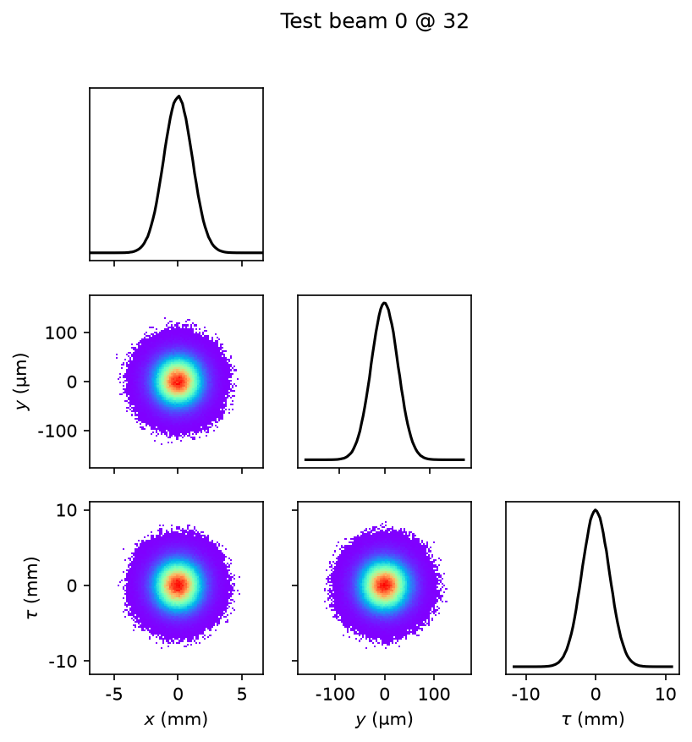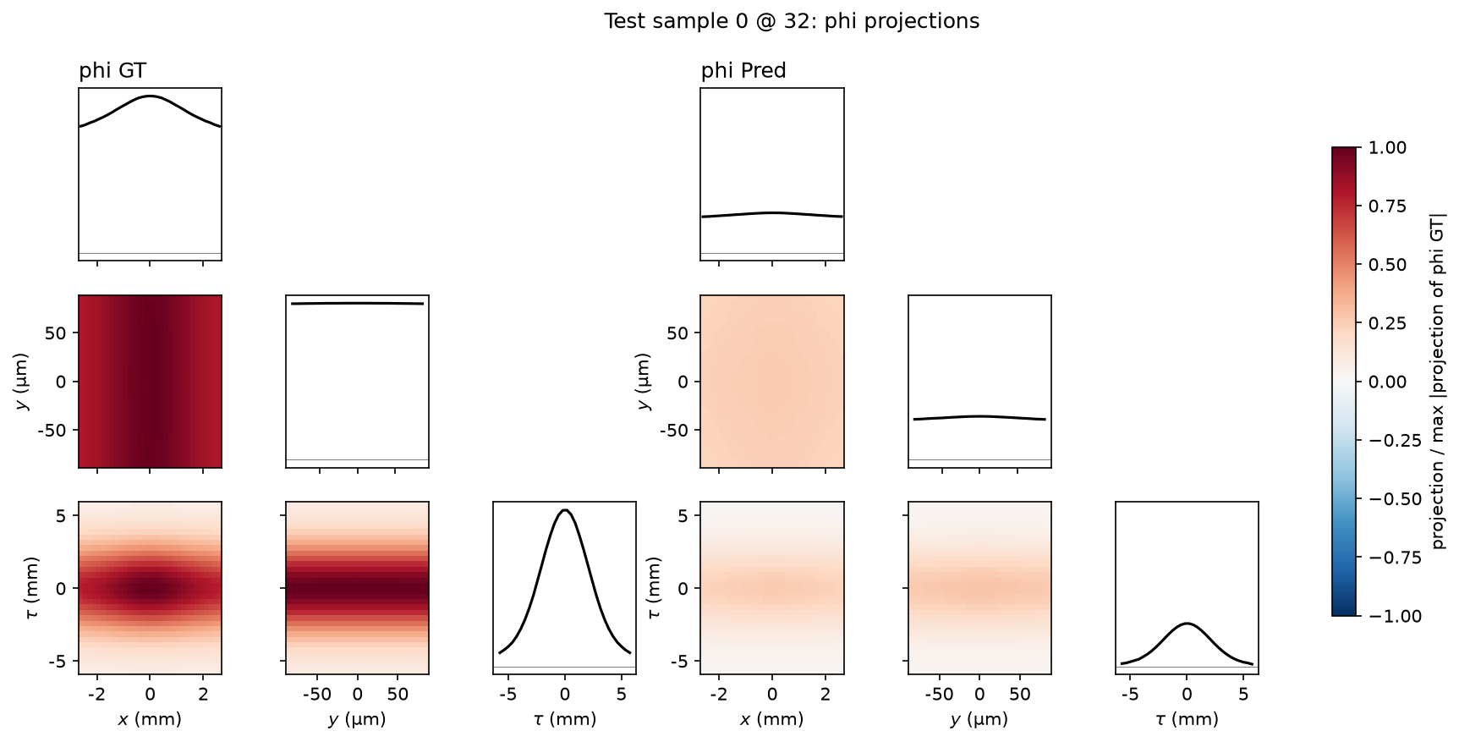

Why the sizes differ
The two figures are drawn on different regions:
- Beam plot: this is a histogram of the raw particles, not the gridded rho. When you pass no range, Cheetah sets each axis to the particles' min/max plus 10% (particle_beam.py:1530). With that many particles, the outermost ones sit at about ±4.5–5σ, so the axes reach about ±5.5σ.
- phi plot: this is drawn on the space-charge grid. SpaceChargeKick uses grid_extent_x/y/tau = 3 by default (space_charge_kick.py:78), so the grid covers ±3σ on each axis.
So the phi plot covers 3σ and the beam plot about 5.5σ, which is roughly half. Your numbers fit this: x is ±2.6 mm vs. ±5 mm, so σx ≈ 0.87 mm. τ is ±6 mm vs. ±11 mm.
Is anything cut off?
Nothing is cut off by the plotting. But the simulation itself only covers part of the space:
- rho: Cheetah only puts charge onto the grid between −3σ and +3σ (space_charge_kick.py:136-141). Particles outside that range are simply left out. For a Gaussian beam that is about 1 − 0.9973³ ≈ 0.8% of the charge. Your model's input rho has the same limits.
- phi: it is calculated on a grid twice as large, but only the part inside the ±3σ region is returned (space_charge_kick.py:317-322). There are no phi values beyond the old plot edges.
Physically, phi keeps going well past 3σ. Your GT plot shows it is still at about 0.8 of its peak at the x edge. Cheetah just doesn't calculate it there. That's fine for the kick, because Cheetah only applies forces to particles inside the grid.

